Lemon Tofu "Cheesecake"
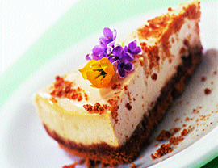
8 Servings
Silken tofu makes a delightfully light and creamy filling for this vegan version of cheesecake. Make it the day before serving to allow its flavors to develop.
- 2 cups graham cracker crumbs
- ¼ cup maple syrup or honey or agave
- ¼ tsp. almond extract or vanilla or lemon
- 1 lb. firm tofu
- ⅓ cup sugar
- 1 Tbs. tahini or almond butter or peanut butter
- ½ tsp. salt
- 1 to 2 tsp. grated lemon zest (grated lemon peel)
- ½ tsp. almond extract or vanilla or lemon
- 1 Tbs. cornstarch dissolved in 2 Tbs. soy milk or rice milk.
- Crust: Preheat oven to 350 degrees. In medium bowl, mix cracker crumbs, syrup and extract until crumbs are moistened. Pour into oiled 9-inch pie plate; press mixture firmly to form crust. Bake 5 minutes; let cool while preparing the filling.
- In food processor or blender, combine remaining ingredients and process until smooth, about 30 seconds. Pour mixture into crust. Bake until top is slightly browned, about 30 minutes. Cool and refrigerate until thoroughly chilled and firm, about 2 hours.
TRISH,
Top with CHIP blueberry sauce before serving or use canned pie filling

