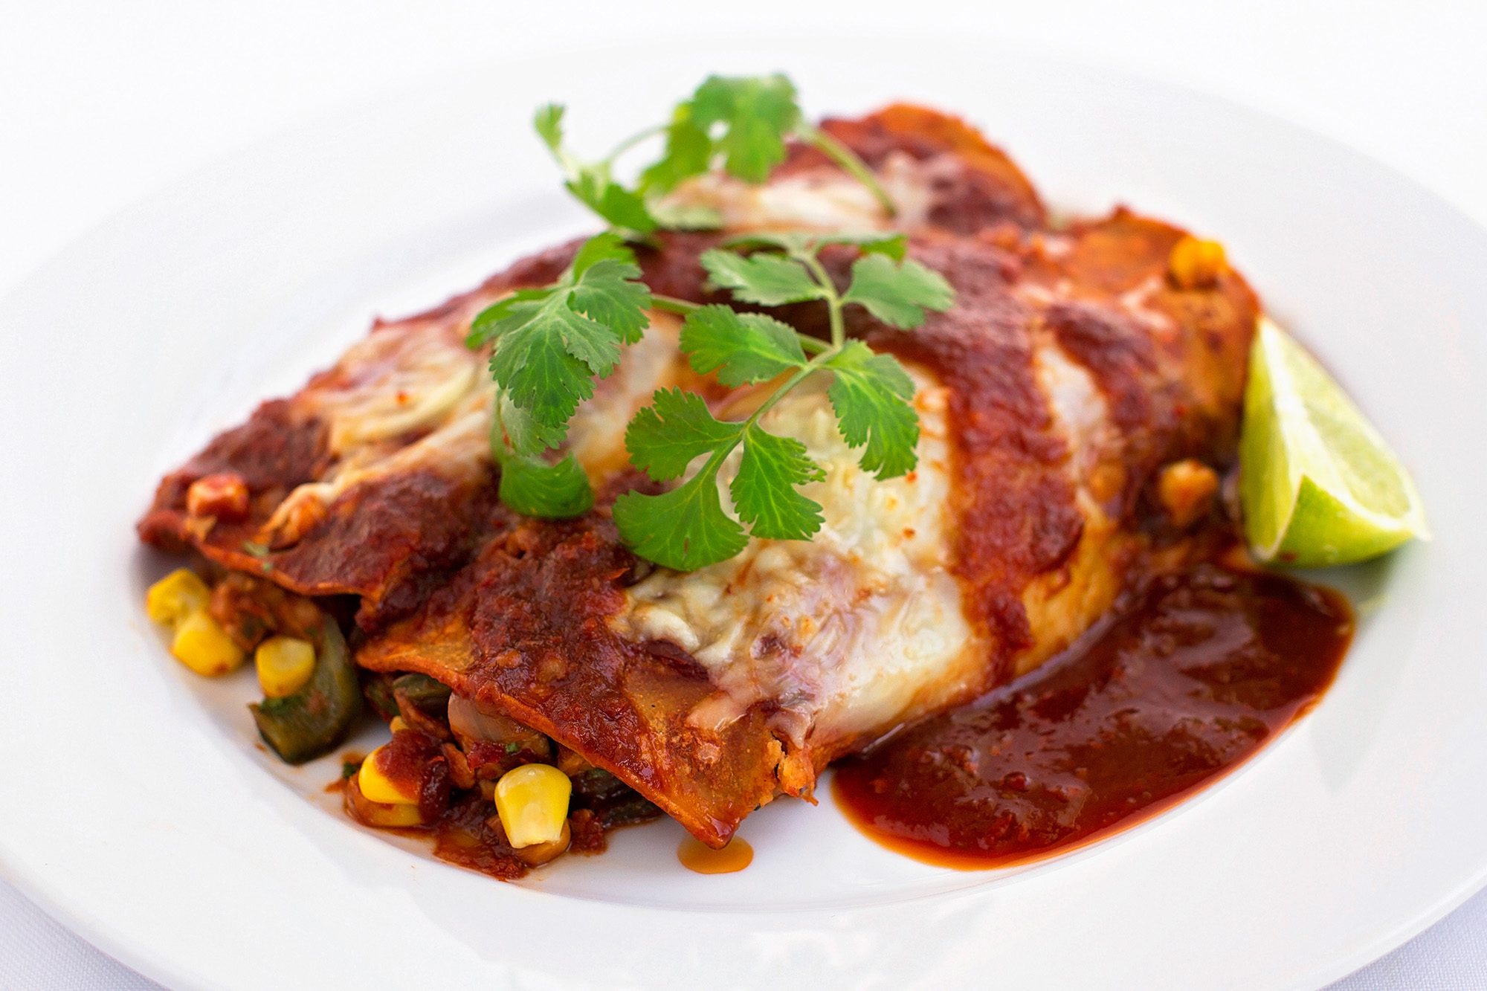
Print Recipe
Serves: 4
Serving Size:
2 enchiladas
Prep:
30 min
Cook:
1 hr
Ready:
1 hr 30 min

Description:
Meaty, protein-rich tempeh takes the place of meat in these Mexican-style enchiladas. You can also make them with cooked pinto beans or your favorite vegetarian ground meat alternative. This filling also makes a great taco or tostada filling. Since cottonseed oil, which is not Ornish Reversal-approved, is an ingredient in many store-bought enchilada sauces, we’ve created an easy, nonfat version using flavorful, mild dried chile peppers. Looking for more information about tempeh? Read Flavorful Ways to Cook with Protein-Rich Soy.

Ingredients:
- FOR ENCHILADA SAUCE:
- 2 OZ dried New Mexican chiles stemmed and seeded
about 10
- 1 1/2 CUPS onion peeled and chopped
- 2 garlic cloves peeled and sliced
- 3 1/2 CUPS water
- 1/4 TEASPOON fine sea salt
- FOR FILLING:
- 2 CUPS fresh pasilla or poblano peppersseeds and ribs removed, chopped
about 2 small peppers
- 1 1/2 CUPS onion peeled and chopped
- 2 TEASPOONS fresh oregano
or 1 teaspoon dried
- 3/4 TEASPOON ground cumin
- 1/4 TEASPOON fine sea salt, divided
- 1/4 CUP water
- 2 CUPS tempeh diced
8 oz
- 1 CUP corn kernels fresh or frozen
- 2/3 CUP cilantro, divided chopped
- 8 6 1/2-in corn tortillas
- 1 CUP nonfat cheese, such as Monterey Jack shredded
optional
- 1 lime cut in wedges
for garnish

Directions:
- To make enchilada sauce, combine dried chiles, onion, garlic, water, and 1/4 teaspoon salt in a medium saucepan over high heat. Bring to a boil. Reduce heat and simmer, stirring occasionally, until onions and chiles are soft, about 25 minutes. Remove from heat.
- Working in batches as needed, pour mixture into a blender. Starting on lowest speed, puree mixture until smooth. Return pureed sauce mixture to the saucepan and set aside. (Enchilada sauce can be prepared up to 14 days in advance. Let cool, transfer to a covered container, and store in the refrigerator until needed.)
- Preheat the oven to 350ºF. To make the filling, combine fresh peppers, onion, oregano, cumin, 1/8 teaspoon of the salt, and water in a large saucepan over medium heat. Bring to a simmer and cook, stirring occasionally, until onions are soft and translucent, about 7 to 10 minutes.
- Add tempeh, corn, remaining 1/8 teaspoon salt, and 1 cup enchilada sauce. Simmer, stirring frequently, for 5 minutes. Remove from heat and stir in 1/3 cup cilantro.
- Wrap tortillas in aluminum foil. Place in oven until tortillas are heated through, about 10 minutes. (Or, to heat in microwave, place tortillas between 2 damp paper towels. Microwave on high until warmed, about 1 minute.)
- To assemble the enchiladas, spread one cup enchilada sauce over the bottom of a 15 x 10 x 2-inch baking pan. Dip each tortilla in the remaining red sauce, letting any extra run back into the saucepan. Place tortilla on a plate. Spoon ½ cup filling down the center of the tortilla. Roll up the sides of the tortilla over the filling. Flip over and place filled tortilla, seam side down, into the prepared baking pan. Repeat with remaining tortillas.
- Spoon one cup of sauce over the enchiladas. Sprinkle with cheese, if using. (Recipe can be prepared to this point up to 8 hours ahead. Cover pan and refrigerate until needed.) Bake enchiladas until enchiladas are golden brown around the edges, about 20 minutes. Reheat remaining enchilada sauce. Garnish each serving with 2 tablespoons red sauce, remaining chopped cilantro and a lime wedge.

