Chick Pea Ala King

½ c. Onions, chopped
½ c. Mushrooms, sliced
1 Tbsp. Oil
2 Tbsp. Water
½ c. Cashew pieces
1 c. Water
4 tsp. Veggie Chicken seasoning
1 tsp. Garlic Powder
4 tsp. Onion Powder
¼ c. Cornstarch
1 Tbsp. Braggs Liquid Amino Acid (or Soy Sauce)
2 Tbsp. Yeast flakes
3 c. Water (or Garbanzo liquid)
2 c. frozen Peas Rinse in colander to thaw before adding to pot.
½ c. chopped Pimentos
2 c. cooked (or canned) Garbanzo beans

1. Sauté first two ingredients in oil & water until onions are clear. Set aside. 2. Blend cashews with 1 c. water & remaining 6 seasonings until very creamy. 3. Boil three cups water. 4. Pour blended mixture into boiling water slowly, stirring constantly until thickened. 5. Add onions, mushrooms, garbanzos, pimentos, and peas. 6. Continue to stir while cooking for 2 more minutes. 7. Serve over brown rice, flat whole grain noodles or toast.

Jane’s 3-2-1- Salad Dressing

3 TBS Balsamic Vinegar
2 TBS Mustard (stone ground or dijon work as well as classic)
1 TBS Pure Maple Syrup
Shake and serve on your favorite salad!

Mac & Not Cheese

2.5 cups diced potatoes
1 cup carrots diced
½ large onion diced
½ water (reserve from boiling the carrots and potatoes)
¼ cup cashews
2 tsp salt
1 TBS lemon juice
½ cup nutritional yeast flakes
1 tsp onion powder
1 tsp garlic powder
1 tsp chicken like seasoning (I use McKay’s or 1 vegetable bullion cube works)
¼ tsp cayenne pepper

Boil potatoes, onion and carrots in water until soft. Place remainder of ingredients in a blender along with the cooked potatoes and carrots (only using ½ cup of the cooking water discard the rest) blend until smooth. Pour over your favorite whole grain pasta.

Sweet Potato Noodle Salad

Veggies:
2 large sweet potatoes
1 cup peas frozen or fresh
1 cup shredded purple cabbage
1 cup chopped fresh kale
1 poblano pepper chopped
½ cup pepitas for garnishing (pumpkin seeds)
¼ cup cilantro, chopped for garnishing

Sauce:
¼ cup of peanut butter or PB2
1 tsp grated ginger or ginger paste
2 garlic cloves
3 TBS low sodium soy sauce or tamari
1 TBS sriracha
1 TBS lime juice
2 TBS maple syrup

Directions:
Peel sweet potatoes. Using a spiralizer create long strips of sweet potato noodles. Set aside.

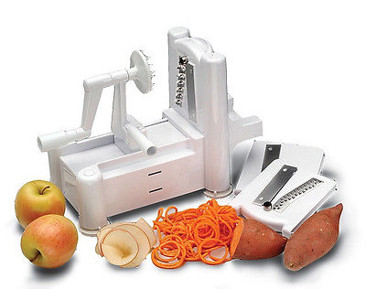
This is a spiralizer tool you can buy them online or at CVS in the as seen on TV section or Bed Bath & Beyond.

Boil a large pot of water and blanch the sweet potatoes until tender (but still holding their shape) about 1-2 minutes depending on the thickness of your noodles. Then
toss the cooked sweet potatoes and remaining vegetable with the dressing.

