Butternut Squash Lentil Soup


INGREDIENTS
8 cups veggie broth
1 yellow onion, chopped
2 cups red lentils, rinsed
3 stalks celery, sliced
3 large carrots, peeled and sliced
1 pound (3 cups) butternut squash, peeled and diced
2 cloves garlic, minced
1/2 teaspoon nutmeg

DIRECTIONS
- Add all ingredients to the slow cooker, and secure the lid.
- Turn it on low, and leave for eight hours (or on high for five hours).
- Give it a stir and enjoy!

Eight Servings per recipe
253 Calories per serving
- Store leftovers i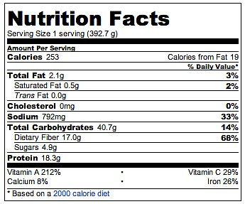n containers in the fridge for three days or in the freezer.
Source: Calorie Count

INFORMATION
Category

Soups/Stews, Crockpot
Yield

8 servings
Cook Time

8 hours

NUTRITION
Calories per serving

253

