- 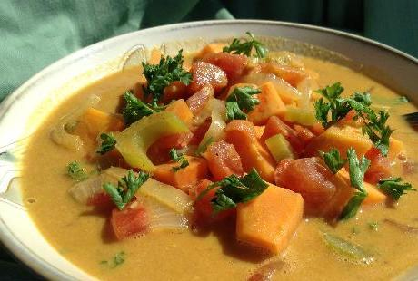
- Yields: 7 servings

Serving Size: 12 oz. or 1 1/2 cups

Prep Time: 15 minutes

Cooking Time: 30 minutes
inShare
This hearty stew is rich with flavors, colors, and nutrients. The coconut, peanut, and curry give this dish an exotic flavor. Easy to prepare and very inexpensive.

Add To Shopping ListIngredients
× HELPFUL HINT: You can add ingredients from this recipe, and others, toYour Shopping List. Un-check the box of each ingredient you do not need and click the Add To Shopping List button. All remaining checkedingredients will be added to your shopping list.
1 Tablespoon Curry Powder 2 Each Onions, sliced in half rings 1 Each Carrots, diced 3 Each Celery, diced 2 Teaspoon Garlic, minced 2 Each Sweet Potatoes, diced into 1/2 inch cubes 2 Cup Vegetable Broth, low sodium 28 Ounce Canned Diced Tomatoes 1 Teaspoon Sea Salt 1/4 Teaspoon Black Pepper 1/2 Cup Chunky Natural Peanut Butter 8 Ounce Coconut Milk 15 Ounce Garbanzo Beans drained and rinsed

Preparation
- Peel and chop sweet potatoes into 1 inch chunks.
- Peel and dice carrots and celery.
- Slice onions into half rings.
- Add the vegetables and remaining ingredients to a pot and cook over high heat until bubbly. Turn down heat and simmer for 30 minutes or until sweet potatoes are tender.

